# An introduction to the projects

This introduction describes the design of the SportsPro Technical Support application and the tech_support database. In addition, it explains how to make the tech_support database available to your applications, how to restore the database so it contains its original data, and how to prepare for developing the application. Finally, it provides some general information about developing the projects.

### The design of the SportsPro Technical Support application

The SportsPro Technical Support application consists of web pages that provide functions for three types of users. First, it lets administrators perform functions such as maintaining the Products, Customers, and Technicians tables of the tech_support database. Second, it lets technicians perform functions such as updating incidents. And third, it lets customers perform functions such as registering products.

Most projects have you add one or more new pages to the SportsPro application. For example, project 6-1 has you add two pages that let an administrator manage the products in the database. If you complete all of the projects for this book, you’ll have a relatively realistic web application.

Note that the first number in a project refers to the chapter in the book. So, for example, you can complete projects 6-1 through 6-5 after reading chapter 6. Similarly, you can complete project 7-1 after reading chapter 7. However, some projects don’t require all of the preceding chapters. That’s why each project lists the required chapters.

## The design of the tech_support database

The tech_support database is used to track technical support incidents. It consists of the seven tables shown in the diagram that follows. The incidents table contains one row for each technical support incident. Each row in the incidents table is related to one row in the customers table, which contains information about the company’s customers; one row in the products table, which contains information about the company’s products; and one row in the technicians table, which contains information about the company’s technical support staff.

In addition, a table named registrations keeps track of the products that are registered to each customer, a table named countries stores the countries of the world, and a table named administrators stores the usernames and passwords for the administrators. Note that the administrators table is not related to any of the other tables.

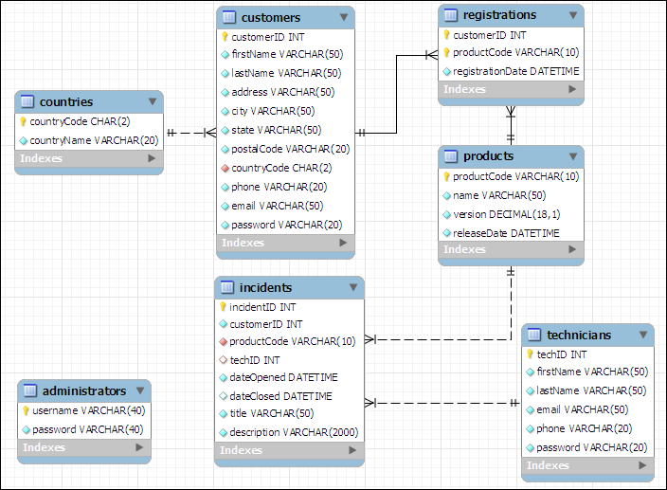

In addition to the column data types shown above, you should know that the customerID, incidentID, and techID columns in the customers, incidents, and technicians tables are AUTO_INCREMENT columns. So, the values of these columns are set automatically when new rows are added to these tables. For more details about this database, you can use phpMyAdmin to view the structure and data that’s stored in the database.

## How to install the database

To install the tech_support database, you can start phpMyAdmin and run the tech_support.sql file that’s provided by your instructor.

**\*\*\*Be sure to look at tech_support.sql and make the necessary changes before executing it. Your database name should be unique\*\***

### How to restore the database

As you test some of the projects that you develop, you’ll need to add, modify, and delete rows in the database. Then, at some point, you may want to restore the original data. To do that, you can use phpMyAdmin to run the tech_support.sql file again. This deletes both the structure and the data of the current tech_support database and restores the original database.

### How to structure your directories

As you develop the web pages needed for each project, you will need to decide where to store the files needed to implement each project. To keep each project independent of other projects, make sure to store each project in its own directory. For example, store the Manage Projects project in its own directory. This directory should have a descriptive name such as manage_projects or project_manager.

### How to format the web pages

As you develop the web pages needed for each project, you will need to apply some formatting to them. To make that easier, you can use the main.css file that’s provided by your instructor. If necessary, you can modify this file, but it contains all of the tags needed to format the pages as shown in this document.

## A starting point for the projects

To make it easy to get started, your instructor may give you the tech_support directory. This directory includes some of the files for a website that can help you get started with the projects. These files include the tech_support.sql file that you can use to create the tech_support database, and a main.css file that you can use to format the web pages. If you run the website, it displays a menu like the one shown here:

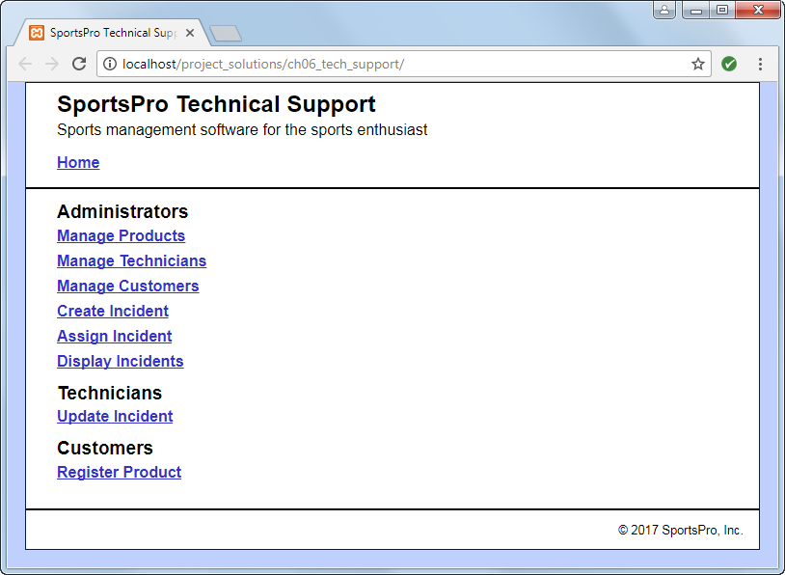

Most projects correspond to one of the links on this menu. However, at this point, if you click on any of these links, they display a message that indicates that the page is under construction. That’s because you still need to write the code that implements these projects.

# The projects

The description of each project includes an image of how the pages should appear in a browser, a description of how the pages operate, and specifications for how the project should be coded. This information is detailed enough for you to complete each project. However, you’ll need to use your best judgment on how to code many of the details. To do that, write the code in the way that you think is best, based on the skills that were presented in the book.

Unless you’re instructed otherwise, you can implement each project using any programming techniques you wish. In some cases, however, the project’s specifications will direct you to use a specific programming technique. For example, a project may direct you to use sessions. In that case, you should implement the project as directed.

Project 6-1: Manage products

For this project, you’ll create an application that lets an admin user view and delete existing products. In addition, this application lets the user add new products by entering the product information into text boxes. (*Required reading: chapters 1-6*)

The Product List page

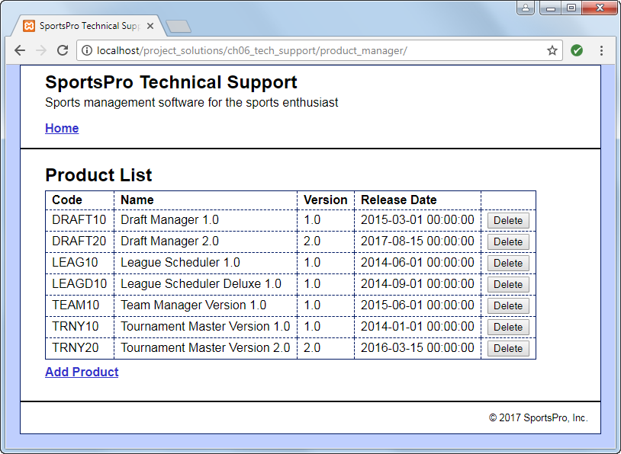

Operation

* When the user clicks the Delete button for a product, the product is deleted from the database.
* When the user clicks the Add Product link, the Add Product page is displayed.
* When the user clicks the Home link, the main menu is displayed.

The Add Product page

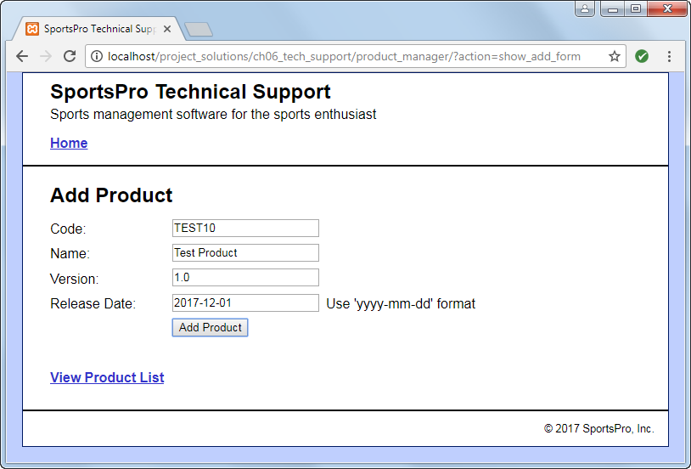

Operation

* When the user enters the data for a new product into the text boxes and clicks the Add Product button, the product is added to the database and the Product List page is displayed again, so the user can view the newly added product.
* When the user clicks the View Product List link, the Product List page is displayed.

Specifications

* Validate the data the user enters on the Add Product page to be sure that the user enters a product code, name, version, and release date. If this data isn’t provided, display an Error page that indicates that a required field was not entered.

Project 6-3: Manage customers

For this project, you’ll create an application that lets an admin user maintain customer data. To start, this application lets the user select an existing customer. Then, the user can view or update the customer’s data. (*Required reading: chapters 1-6*)

The Select Customer page

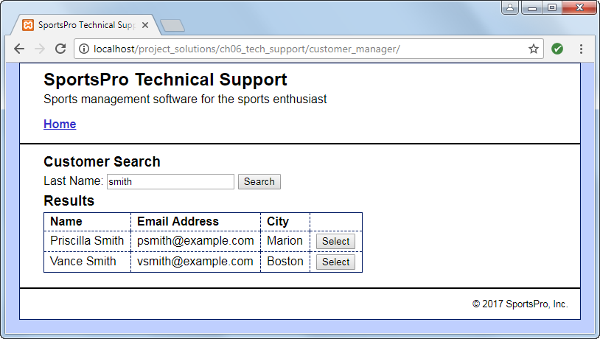

Operation

* When the user enters a last name and clicks the Search button, the application displays a table of customers with the specified last name.
* When the user clicks the Select button for a customer, the data for that customer is displayed on the View/Update Customer page.

The View/Update Customer page

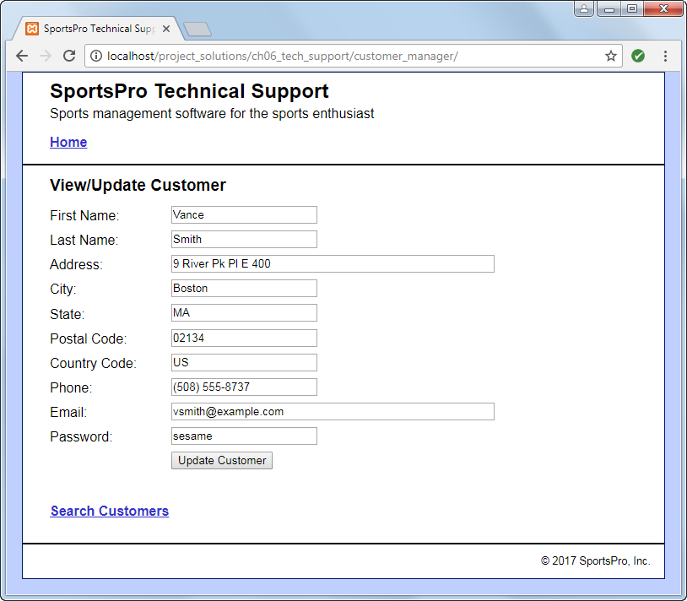

Operation

* When the user clicks the Update Customer button for a customer, the application updates the database. The user can also click the Back button or the Search Customers link to return to the Search Customers page without modifying the database.

Specifications

* US is the country code for the United States.